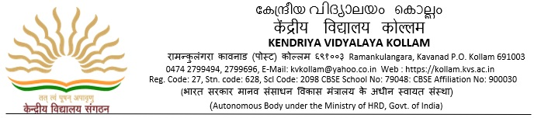

F .No. 310111/1/2022-23/KVK / Dated: 28-05-2024

Extension Date of submission of Tender

Sub: Extension of date of Tender for the Supply of Identity Card to Students / Staff of the Vidyalaya

Madam/Sir,

With reference to this office letter F .No. 310111/1/2022-23/KVK / Dated: 28-05-2024 the date of receipt of tender is extended up to 31st May 2024 up to 02.00 p.m

Principal